**Design Document**

**General Ethos**

The website which I am developing needs to strike a balance between a fun and colourful aesthetic which appeals to children and a website of a more informative, corporate nature, detailing information about the company’s founders, news and other information which will not appeal to children. For both sets of users, the site should be easy to navigate and should load fast. The layout should be clean and consistent to make navigation as simple as possible.

**Site Map**

The light structure makes it easy for the user to navigate to the information they want by drilling down through these levels. As there are few levels and very little branching beyond the splash page it is easy for the user to access the content they want without having to follow a long pathway of links. This is especially important as child users may otherwise find it easy to get lost amongst news articles or founder pages and would otherwise struggle to find their way to the puzzle game page which they initially wanted to view. This structure follows suggestions from http://webstyleguide.com/wsg3/3-information-architecture/3-site-structure.html

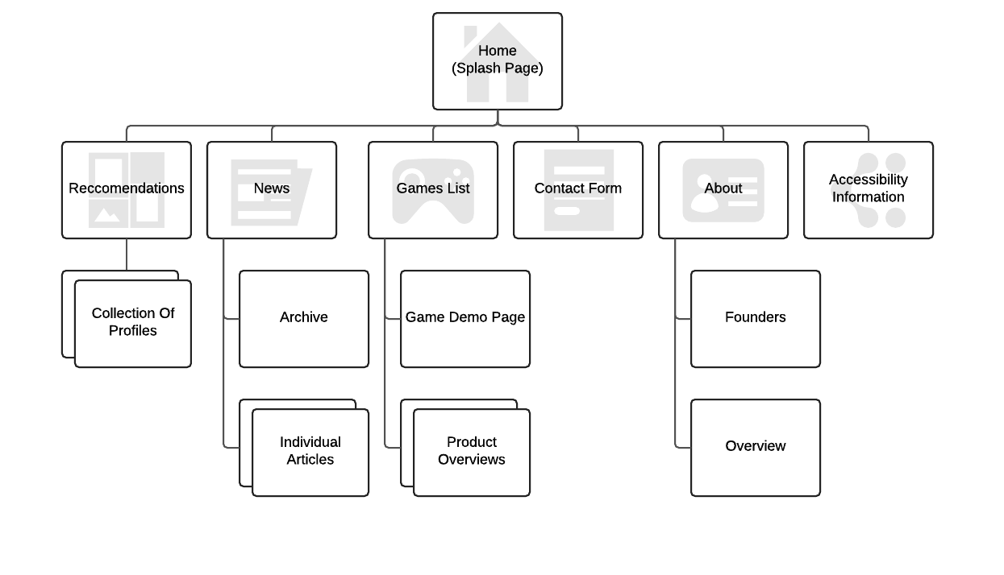

Figure – Site map

**Accessibility**

The website will incorporate a number of accessibility options to ensure that it easily navigable and fluid for all users. To ensure accessibility, the site will adhere to the W3C’s WCAG guidelines and principles (found at https://www.w3.org/WAI/intro/wcag.php). The website will follow these principles as follows:

* **Perceivable**
  + Non-text content including videos, image and audio will have a text counterpart so that the content remains accessible to those who have visual or hearing impairments.
  + Decorative content, like the border featured at the bottom of each page is implemented so that it will be ignored by screen reader software.
  + All content will be found within explicit tags such as <header> or a <div> with a specific id. These landmarks make it easy for people who use a screen reader to follow the page.
  + Sans-serif fonts will be used for readability.
* **Operable**
  + The site will be fully operable via a keyboard without requiring specific timings for keystrokes. The site will be structured in such a way that keyboard navigation doesn’t cause jumping and instead the user can traverse the page intuitively.
* **Understandable**
  + HTML file contains language attribute for easy use with screen readers, TTS programs and translators.
  + Site assumes a low reading level for both adult and child users. Language is kept simple so that users can easily understand page content.
  + Errors are output if found on the contact form and context-sensitive help is provided using tooltips.
  + The navigation menu is consistent so that the page is intuitive.
* **Robust**
  + HTML is well-formed so that content is always interpreted in the same way by the browser. IDs are never duplicated and are used to identify unique parts of the page.
  + All content is compatible with accessibility technology so all users receive identical information from a page

**Design Mock-Ups**

Below are mock-ups for each design. Each page uses two breakpoints as to give three different appearances of the page depending on the device on which it is viewed. This makes sure the page is aesthetically and informatively consistent across all devices, without having so many breakpoints that it becomes confusing for the user to navigate.

**Splash Screen**

The splash screen is designed to be clean and intuitive. A button labelled “Our Games” is bold and easily visible across all three variants of the splash screen so that children can access the portion of the website which is of interest to them with a single click. Users interested in the corporate side of the site can also quickly access the portion of the site detailing company information. This page quickly allows a user to navigate to the information of most relevance to them.

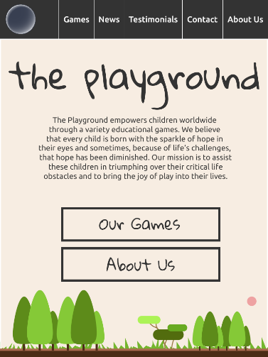 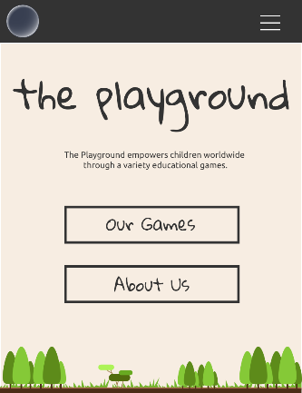

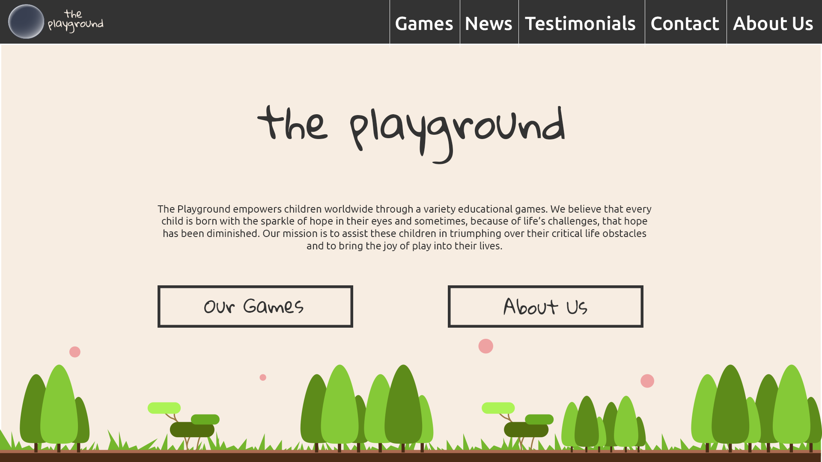

Figure 2 – Splash/Home Page

**Games**

The games page features a list of boxes, each of which links to an individual page for a puzzle game. Each box features a piece of artwork with the title of the game overlaid. On hover, the overlaid text changes to a short textual description of the game. For operability on mobile, a tap will change the box to display a description while a double tap will send the user to the individual game page.

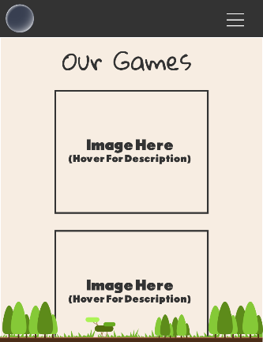

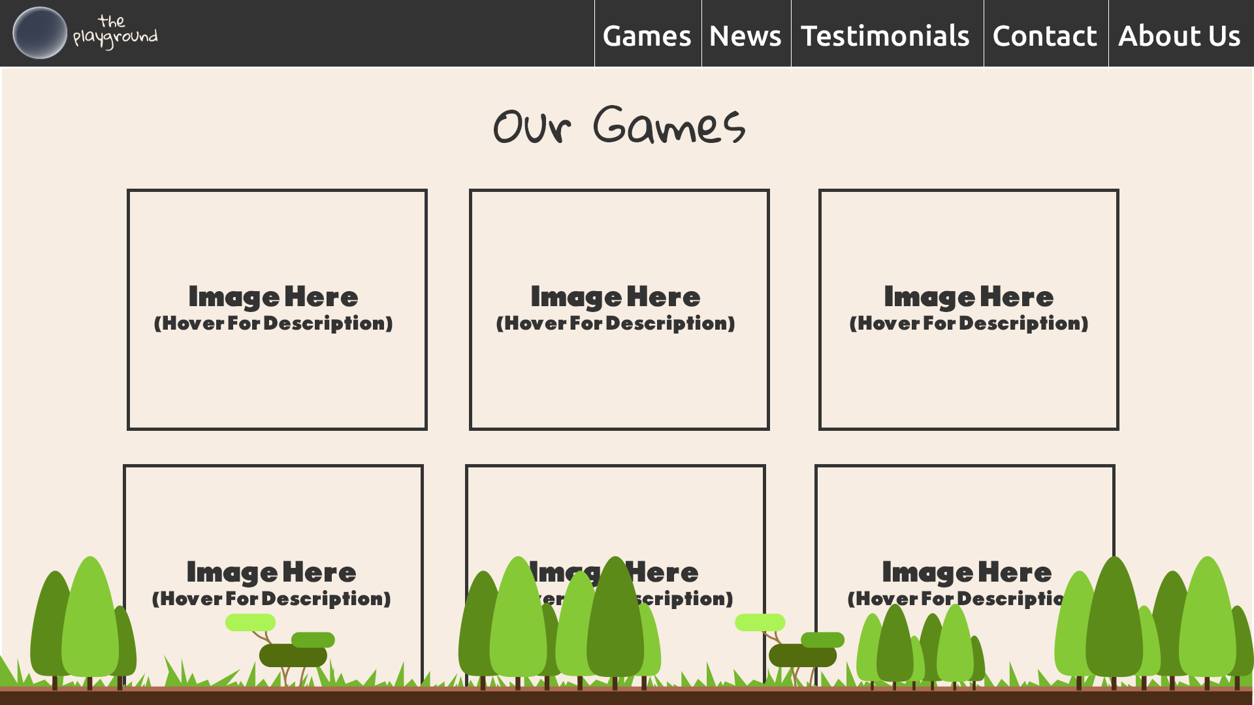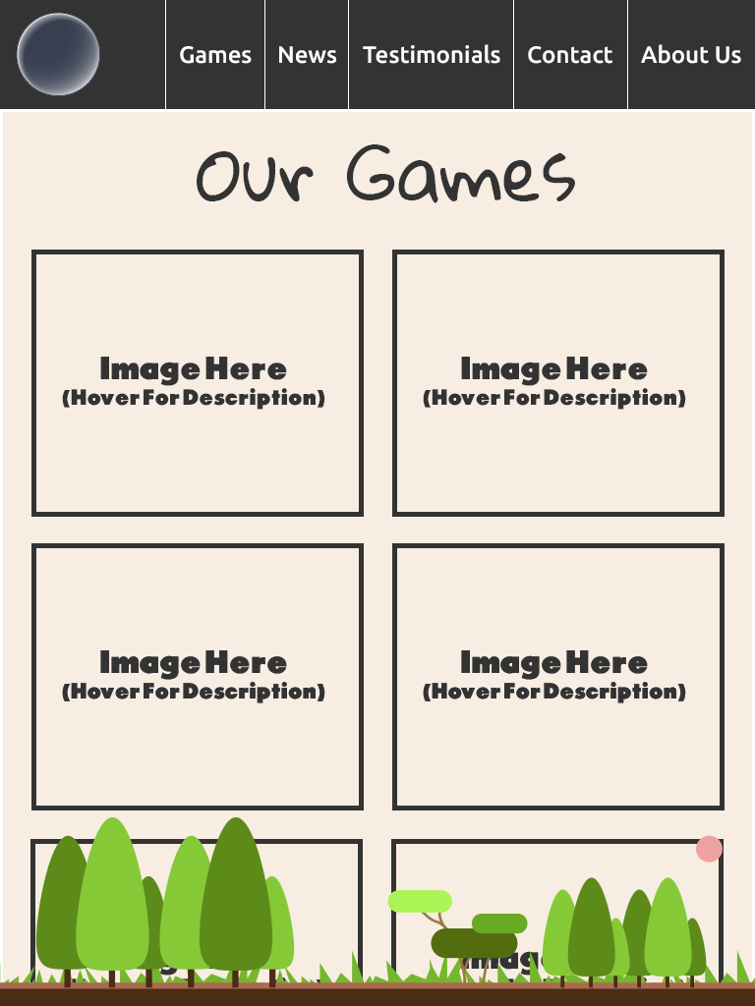

Figure 3 – Games Page

**News**

The news page displays a list of news articles. They are placed in reverse chronological order so that visitors can find the newest information first. Articles cover just over two thirds of the page while an archive is floated to the right so that users can easily access older articles. The narrow version of the site reduces the news article box down to just a single column with the archive still floated right. The mobile version removes the archive bar for readability on a mobile device.

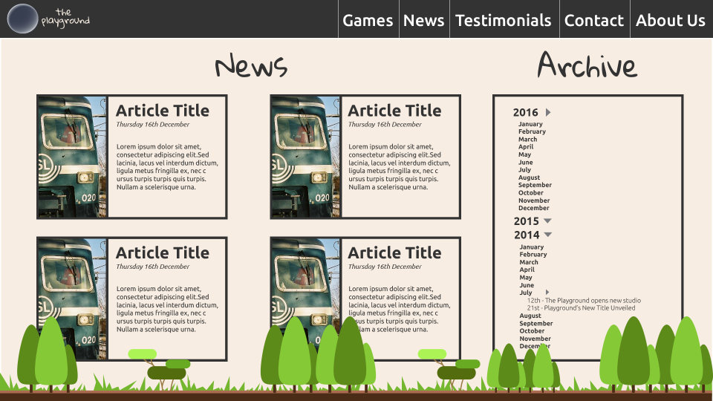 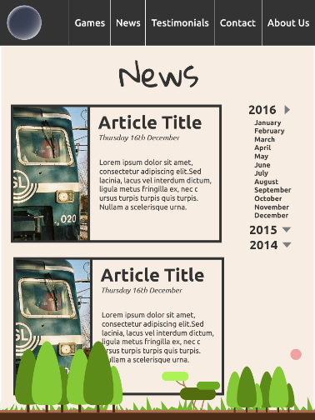 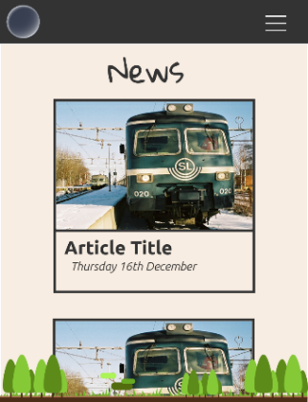

Figure 4 – News Page

**Article**

The article page has been designed so that it feels immediately intuitive to anybody who has read a news article online. Users should quickly recognise the layout of this page as its presented in a standard format used across the web.

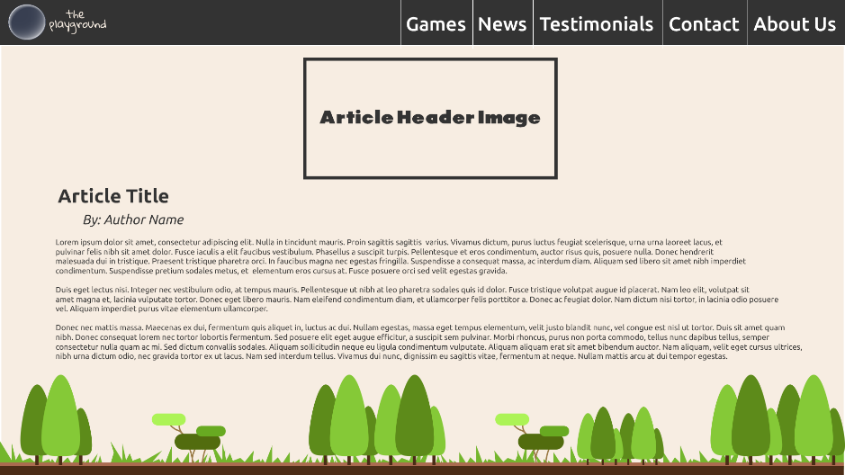 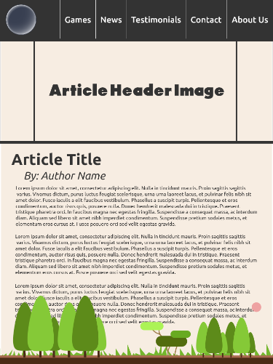 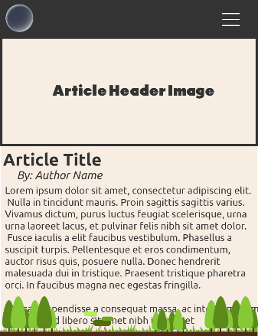

Figure 5 – Article Page

**Reviews**

This page features an almost full screen video. A graphic has been included to tell the user that more content is available if they scroll down as it may not be immediately obvious to all users. Upon scrolling, JavaScript will be used to disable this hint.

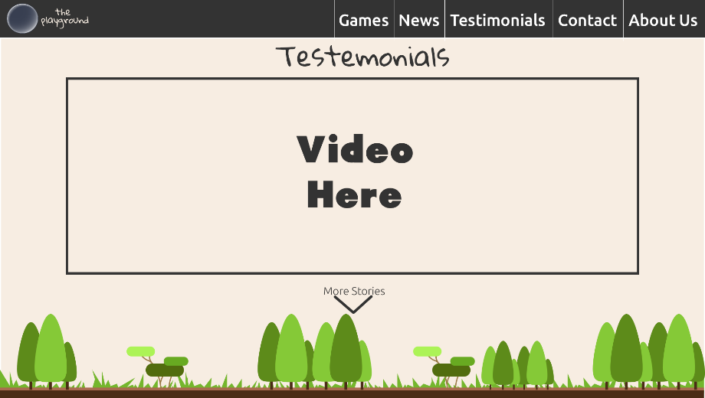 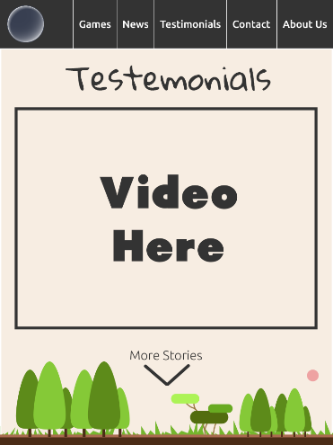 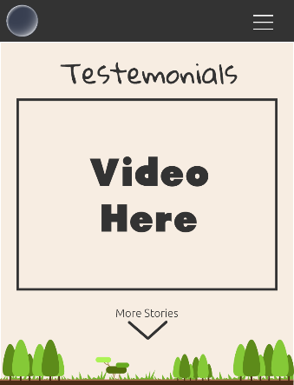

Figure 6 - Testimonials Page Full

View once user scrolls down.

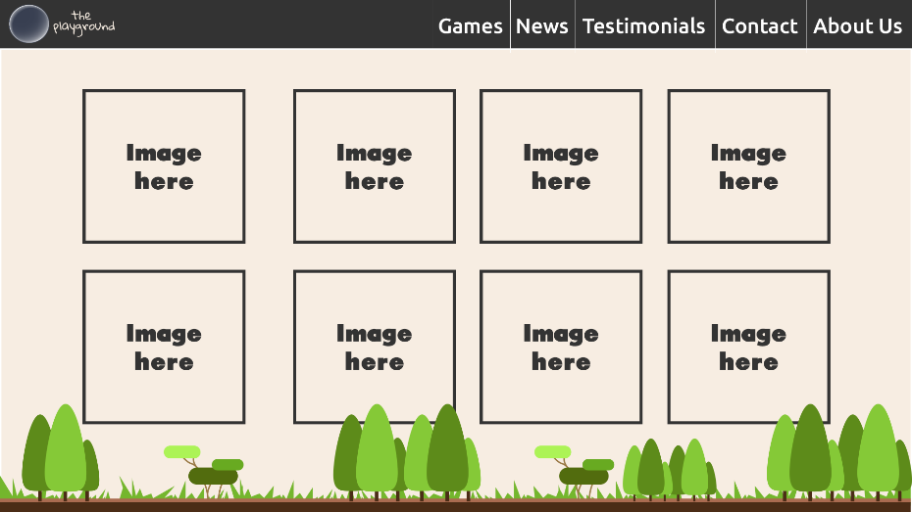 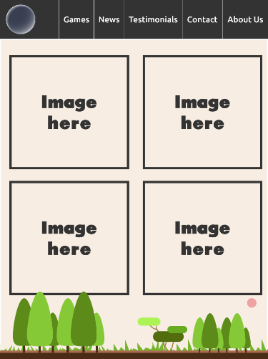 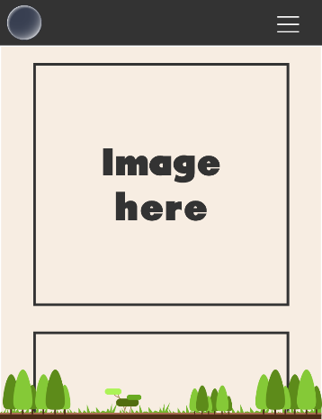

Figure 7 – Testimonials Page Scrolling

**Contact**

In desktop mode, all content is placed on the screen in two columns to give the user quick access to all functions of the page. In narrow and mobile mode, the flexbox container will adjust so that the email form remains at the top of the screen and other contact information and social media links will wrap beneath so that they are further down the page.

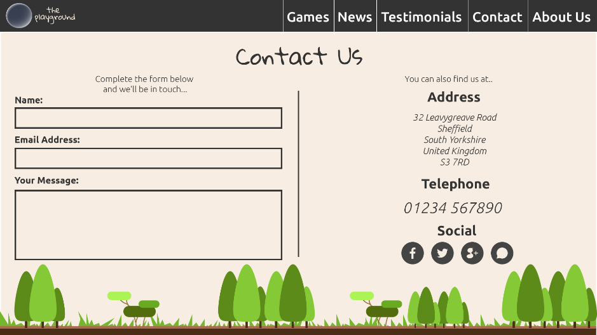 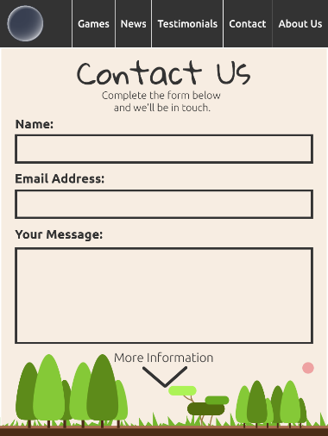 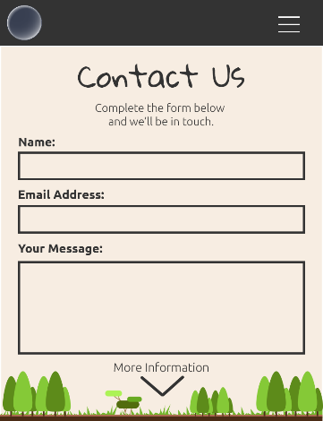

Figure 8 - Contact Us Page Top

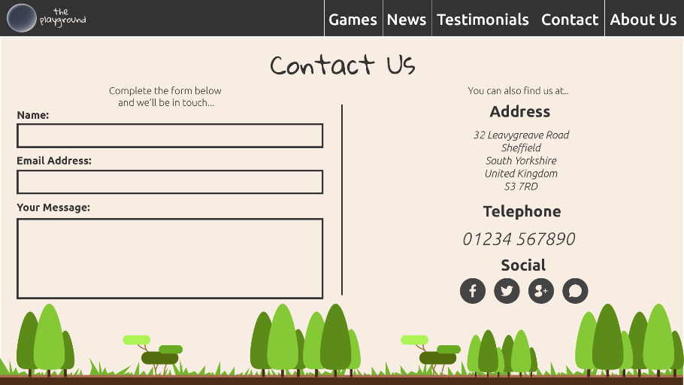 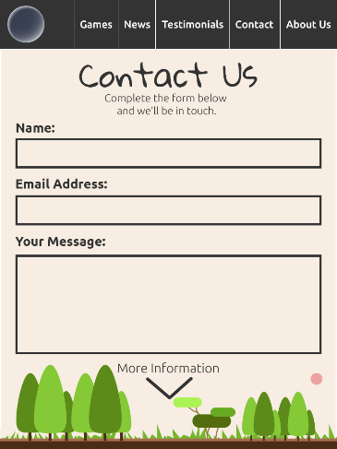 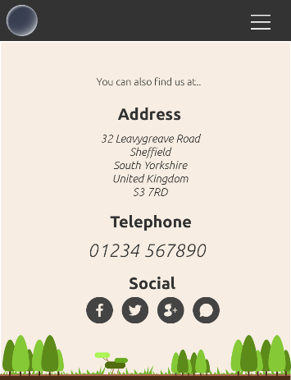

Figure 9 – Contact Us Page Scrolling

**Founders**

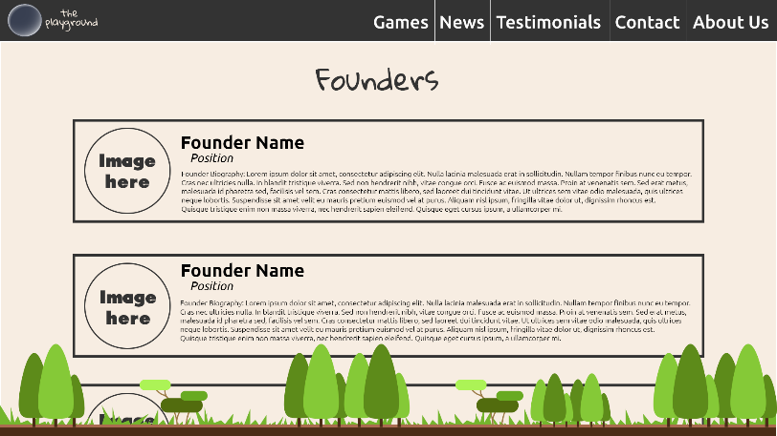 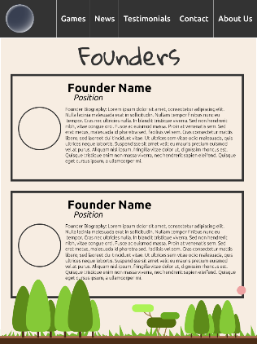 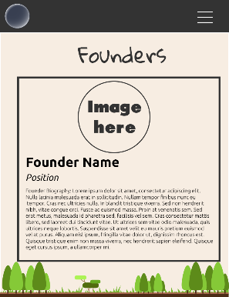

Figure 10 – Founders Page

**Menu-System**

I have chosen a mixture between “Top Nav” and “Toggle” menu for navigation. Desktop and Narrow devices will use a static menu, while mobile devices will use a toggle drop-down menu. Both options have been chosen because they are standard navigation systems seen across the web, they feel familiar to users. A top navigation bar would be too cramped on a mobile device; hence a media query will be used to switch to a dropdown menu.



Figure 10

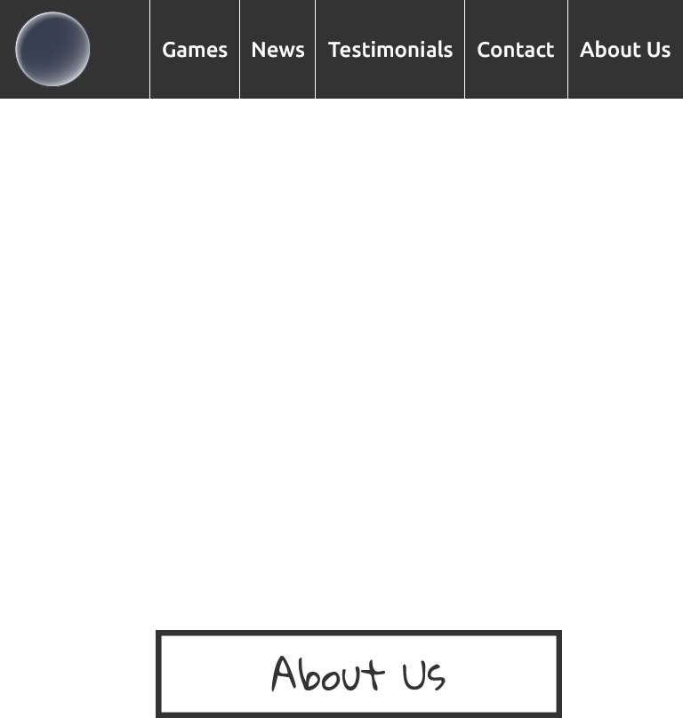

Figure 11



Figure 12

**Game Design – Matching Pairs**